Stevenson-Carson School District
2018-2019FY Budget Workshop
6/28/18

DRAFT

Prepared by Kris Grindy, Business Manager

General Fund
2018-2019 Operating Budget
Projected Beginning Fund Balance: $ 1,623,053
Revenues/Other
Financing Sources | 1718FY Budget | 1819FY Budget | Difference
Local Taxes | $ 1,489,600 | $ 1,530,000 | $ 40,400
Local Support NonTax | $ 468,834 | $ 275,590 | $ (193,244)
State, General Purpose | $ 6,337,769 | $ 7,272,087 | $ 934,318
State, Special Purpose | $ 2,030,997 | $ 2,374,671 | $ 343,674
Federal Gen/Special Purp | $ 976,955 | $ 2,293,731 | $ 1,316,776
Revenues, Other Entities | $ 490,811 | $ 663,736 | $ 172,925
Total | $ 11,794,966 | $ 14,409,815 | $ 2,614,849
Expenditures | 1718FY Budget | 1819FY Budget | Difference
Regular Instruction | $ 6,265,874 | $ 7,399,845 | $ 1,133,971
Special Ed Instruction | $ 1,281,242 | $ 1,507,934 | $ 226,692
Vocational Ed Instruction | $ 289,687 | $ 428,110 | $ 138,423
Compensatory Instruction | $ 920,126 | $ 1,042,112 | $ 121,986
Other Instructional Prog | $ 427,199 | $ 1,091,556 | $ 664,357
Support Services | $ 2,774,890 | $ 2,940,258 | $ 165,368
Total | $ 11,959,018 | $ 14,409,815 | $ 2,450,797
Net Position | $ (164,052) | $ - | $ 164,052

Projected Ending Fund Balance: $ 1,623,053
- 2011-2012 Ending Fund Balance = $5,361,037
- 2012-2013 Ending Fund Balance = $4,617,451
- 2013-2014 Ending Fund Balance = $4,079,055
- 2014-2015 Ending Fund Balance = $3,884,004
- 2015-2016 Ending Fund Balance = $3,366,166
- 2016-2017 Ending Fund Balance = $1,911,202
- 2017-2018 Est. Ending Fund Balance = $1,623,053

Revenues
18-19 FY Revenue Budget = $14,409,815
66.9% - State Funding – Apportionment, Transportation, Grants $ 9,646,758
15.9% - Federal Funding – Special Education, Grants $ 2,293,731
17.1% - Local Funding – Levy, Local Fees, Other Entities $ 2,469,326

Expend by Object Code | 1718FY Budget | 1819FY Budget | Difference
Certificated Salaries | $ 3,471,968 | $ 4,222,589 | $ 750,621
Classified Salaries | $ 2,238,644 | $ 2,489,678 | $ 251,034
Benefits/Payroll Taxes | $ 2,659,339 | $ 3,066,419 | $ 407,080
Supplies and Materials | $ 618,828 | $ 698,762 | $ 79,934
Purchased Services | $ 2,854,814 | $ 3,756,792 | $ 901,978
Travel | $ 85,927 | $ 84,494 | $ (1,433)
Capital Outlay | $ 28,498 | $ 90,081 | $ 61,583
Total | $ 11,958,018 | $ 14,408,815 | $ 2,450,797

Enrollment
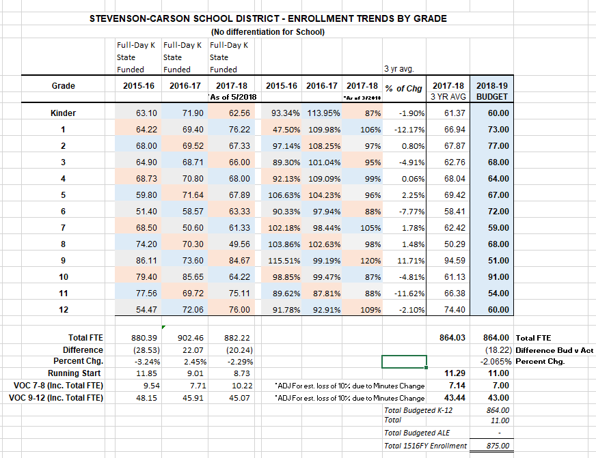

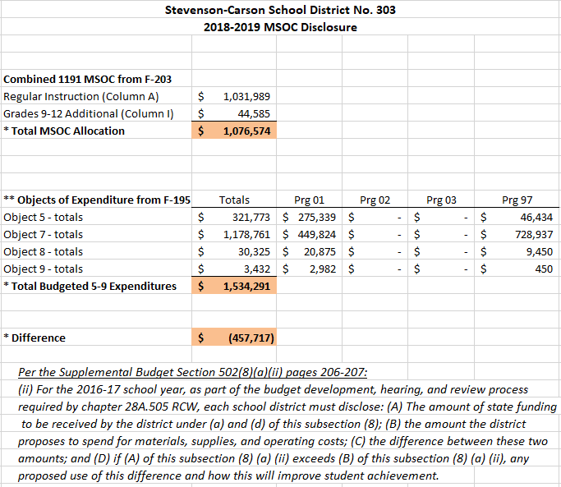

Capital Projects Fund
2018 – 2019 Budget
Estimated Beginning Fund Balance: $126,446
Revenues | 1718FY Budget | 1819FY Budget | Difference
Local Taxes | $ - | $ - | $ -
Local Support NonTax | $ 500 | $ 500,500 | $ 500,000
State, General Purpose | $ - | $ - | $ -
State, Special Purpose | $ 350,000 | $ 178,186 | $ (171,814)
Federal Gen/Special Purp | $ - | $ - | $ -
Revenues, Other Entities | $ - | $ - | $ -
Total | $ 350,500 | $ 678,686 | $ 328,186
Expenditures | 1718FY Budget | 1819FY Budget | Difference
10 Sites | $ - | $ 154,800 | $ 154,800
20 Buildings | $ - | $ 106,746 | $ 106,746
30 Equipment | $ 44,794 | $ 76,686 | $ 31,892
40 Energy | $ 596,000 | $ 340,454 | $ (255,546)
50 Sales & Lease EXP | $ - | $ - | $ -
60 Bond Insurance EXP | $ - | $ - | $ -
90 Debt | $ - | $ - | $ -
Total | $ 640,794 | $ 678,686 | $ 37,892
Net Position | $ (290,294) | $ - | $ 290,294

Projected Ending Fund Balance: $126,446

Associated Student Body Fund
2018 – 2019 Budget
Estimated Beginning Fund Balance: $138,987
Revenues | 1718FY Budget | 1819FY Budget | Difference
1000 General Student Body | $ 39,550 | $ 64,200 | $ 24,650
2000 Athletics | $ 79,981 | $ 93,000 | $ 13,019
3000 Classes | $ 8,580 | $ 5,700 | $ (2,880)
4000 Clubs | $ 52,150 | $ 94,500 | $ 42,350
6000 Private Money | $ 2,000 | $ 4,400 | $ 2,400
Total | $ 182,261 | $ 261,800 | $ 79,539
Expenditures | 1718FY Budget | 1819FY Budget | Difference
1000 General Student Body | $ 45,100 | $ 59,550 | $ 14,450
2000 Athletics | $ 82,930 | $ 88,150 | $ 5,220
3000 Classes | $ 9,300 | $ 6,500 | $ (2,800)
4000 Clubs | $ 60,069 | $ 112,388 | $ 52,319
6000 Private Money | $ 5,659 | $ 4,350 | $ (1,309)
Total | $ 203,058 | $ 270,938 | $ 67,880
Net Position | $ (20,797) | $ (9,138) | $ 11,659

Projected Ending Fund Balance: $129,849

Transportation Vehicle Fund
2018 – 2019 Budget
Estimated Beginning Fund Balance: $180,164
Revenues/Other
Financing Sources | 1718FY Budget | 1819FY Budget | Difference
Local Taxes | $ - | $ - | $ -
Local Support NonTax | $ - | $ - | $ -
State, General Purpose | $ - | $ - | $ -
State, Special Purpose | $ 51,192 | $ 72,907 | $ 21,715
Federal Gen/Special Purp | $ - | $ - | $ -
Revenues, Other Entities | $ - | $ - | $ -
Total | $ 51,192 | $ 72,907 | $ 21,715
Expenditures | 1718FY Budget | 1819FY Budget | Difference
30 Equipment | $ 109,000 | $ 180,000 | $ 71,000
60 Bond Levy Inssuance | $ - | $ - | $ -
90 Debt | $ - | $ - | $ -
Total | $ 109,000 | $ 180,000 | $ 71,000
Net Position | $ (57,808) | $ (107,093) | $ (71,000)

Projected Ending Fund Balance: $ 73,071

